**INFORMATION**

**NAME: Mukesh Chandel**

**PASSPORT SIZE PIC:** 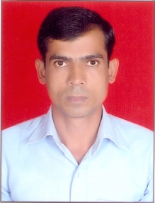

**Highest Qualification: M.A. & PGDCA**

**Designation: Lab Instructor**

**LAB No. Assigned: IBM**

**Email Id: mukeshchandel.cse@jecrc.ac.in**

**Experience: 09 Years**